1. 
2. **Agenda**: How to configure the proxy setting in postman to capture the requests flowing in web browser.
3. Actually, after setting proxy, all the requests from browser would go through postman so it can then intercept the requests.
4. 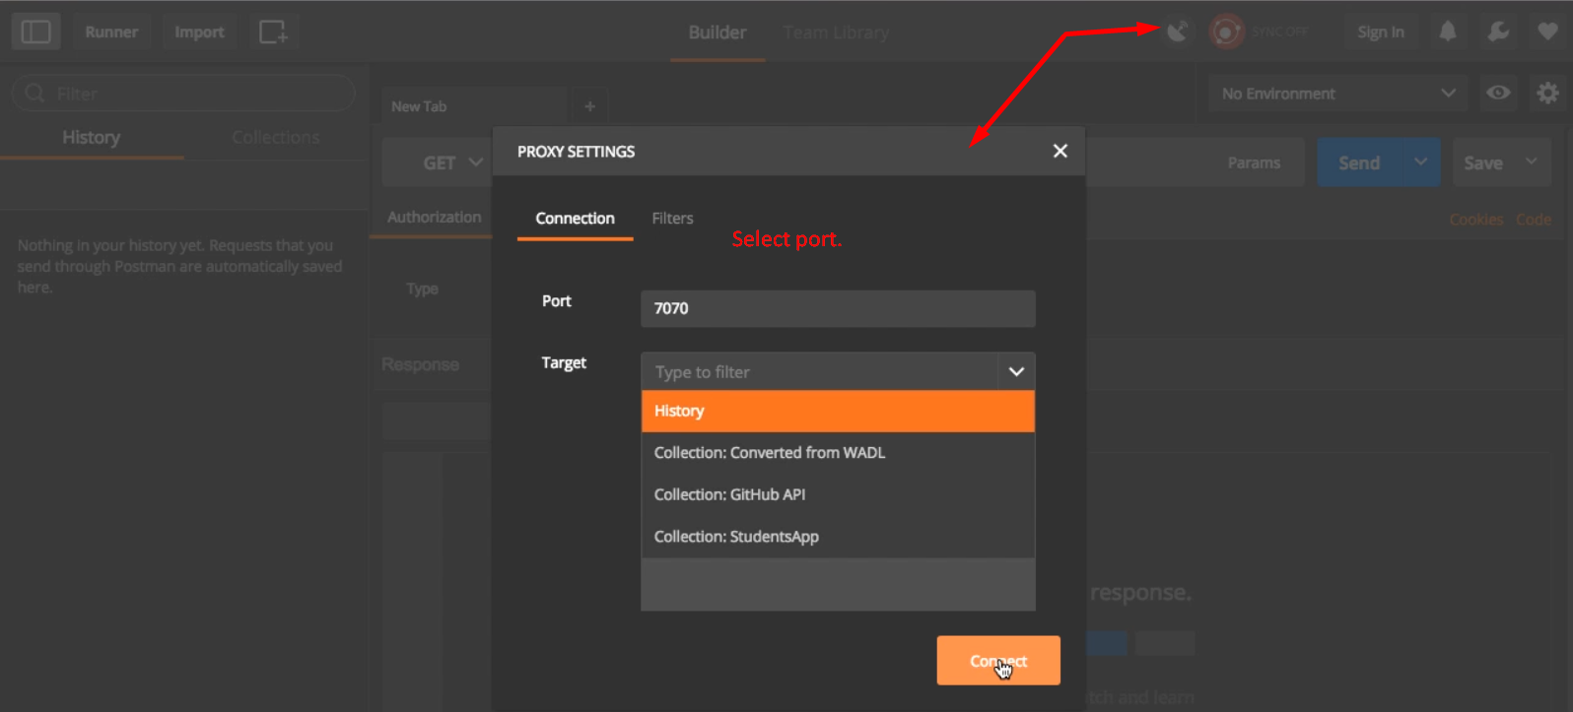 
5. 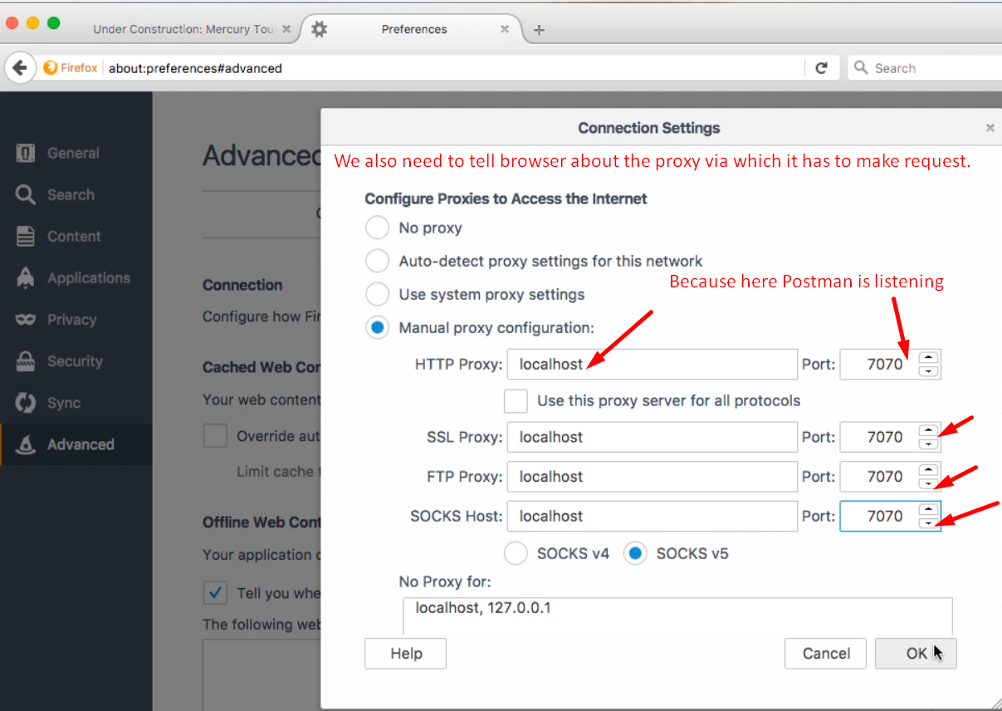
6. 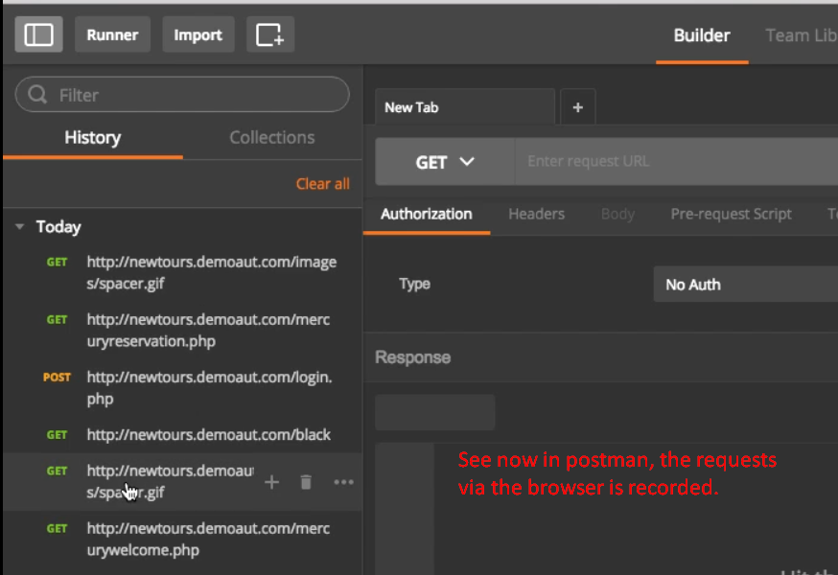
7. 